M3901 SP_Flash_Tool USB Upgrade Instructions

Please make sure to install the USB driver before upgrading. If it is not installed, install the SP_Drivers driver according to the 3901 item USB driver manual in \Upgrade\DriverInstall.exe.

Upgrade method
upgrade tools：SP_Flash_Tool_exe_Windows_v5.1748.00.000\flash_tool.exe

Upgrade scenario
- In the USB upgrade package Download_Tool file, double-click to open the Flash tool tool.
Download-Agent selects "MTK_AllInOne_DA.bin" by default, as shown in the figure.。
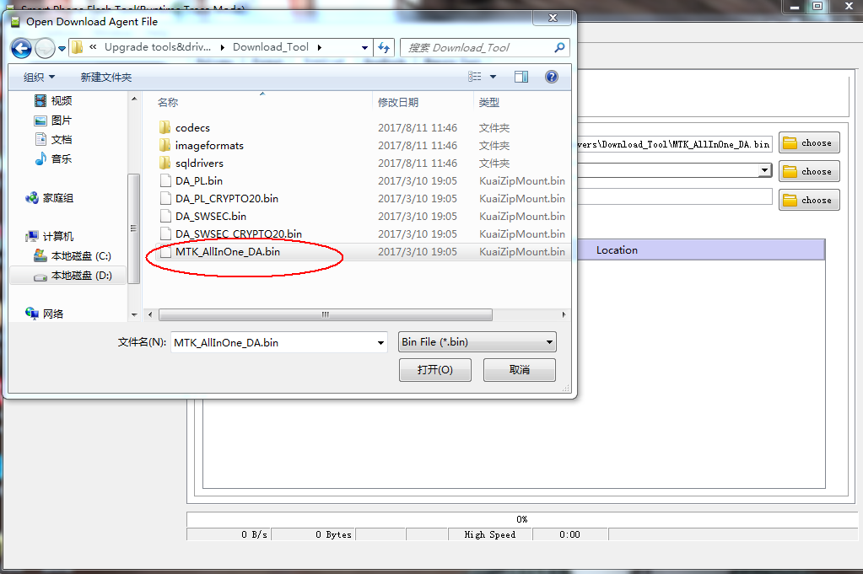
- Scatter-loading File selects "MT6739_Android_scatter.txt" , as shown in the figure.
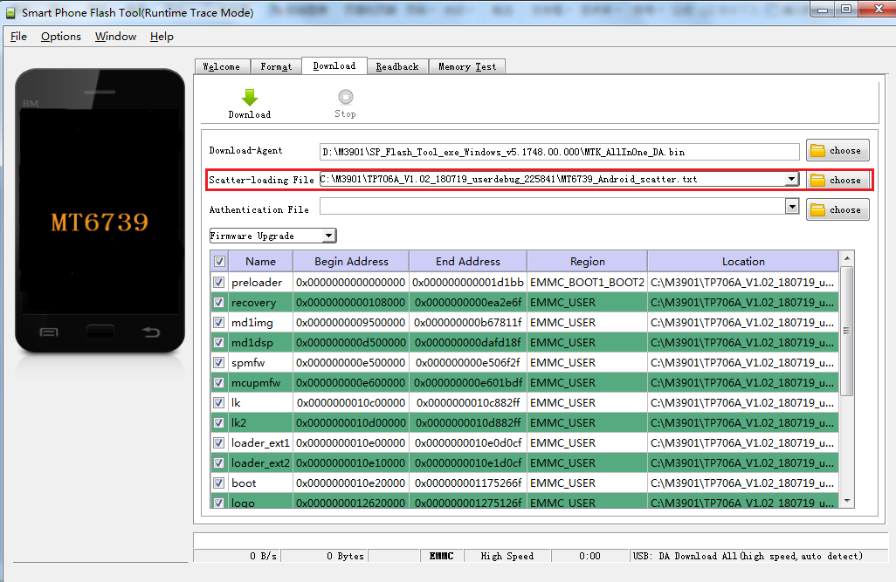
- The upgrade method selects the third item of the pull-down menu, which is "Firmware Upgrade", as shown in the figure.
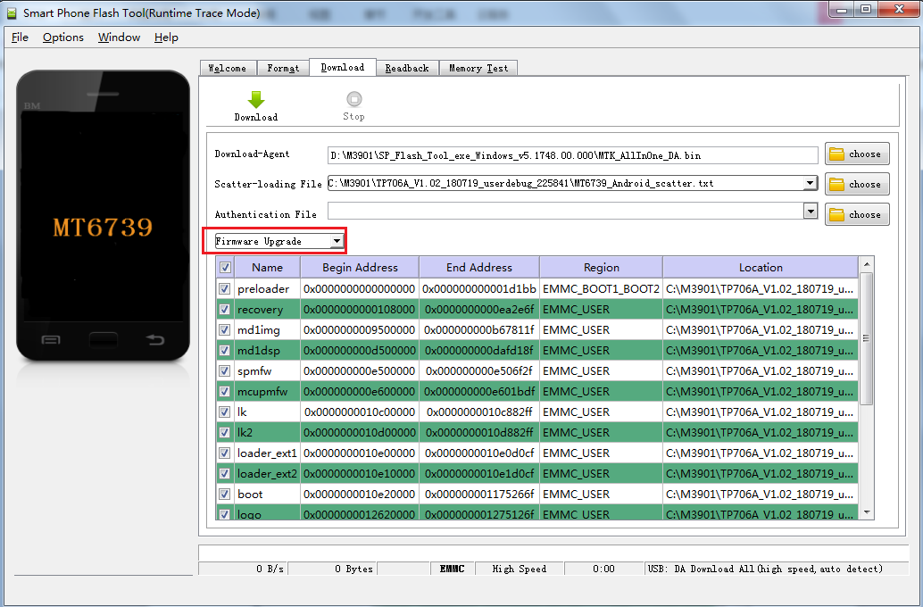
- Click Download。
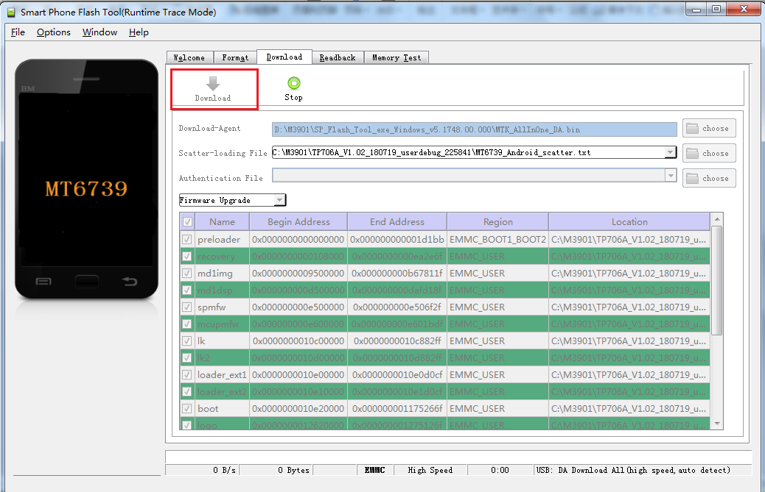
4. After the phone is turned off, connect the USB cable to upgrade. The upgrade is successful.

